Cross-quantilogram: GBPUSD and NZDUSD
Method 20 / daily log returns / expanding quantiles / Alpari D1 full available history

Study setup
Logical pair: GBPUSD , NZDUSD
Broker symbols: GBPUSD_i , NZDUSD_i
Snapshot: 2026-11-03_majors_alpari_D1
Timeframe: D1
Matched return window: 1999-01-05 to 2026-11-02 (UTC bar dates)
Matched return count n: 7203
Dropped unfinished last bar dated 2026-11-03 UTC after a tick-volume check against the prior complete day.
Quantiles: expanding window, min history 252 days
tau in [0.05, 0.2]; k=0..10; headline tau=0.05, k=1
Complete matched rows (Excel): GBPUSD-NZDUSD_CQ_D1.xlsx
Complete matched rows (HTML table): GBPUSD-NZDUSD_CQ_D1_data.html

Method carried forward
The cross-quantilogram rho_tau(k) measures linkage among centered quantile-hit indicators of matched daily log returns of close, ln(close_t / close_t-1). Quotes are not inverted. At each date t, the tau-quantile uses only returns through t (expanding window) after a minimum history of 252 days. Hits are h_t = 1(r_t < q_t) - tau. rho_tau(k) is the normalized cross-product of h_x,t with h_y,t+k. Levels tau in {0.05, 0.20} and lags k=0..10 are pre-specified; headline is tau=0.05, k=1 both directions. Same-sample Pearson r is a side check. This is not causation and not a trading signal.

Results (headline)
rho_GBPUSD->NZDUSD(tau=0.05,k=1): 0.072951
rho_NZDUSD->GBPUSD(tau=0.05,k=1): 0.057146
rho_GBPUSD->NZDUSD(tau=0.20,k=1): 0.035845
rho_NZDUSD->GBPUSD(tau=0.20,k=1): 0.017482
Pearson r: 0.530079

CQ table (tau=0.05)
k | rho_GBPUSD_to_NZDUSD | n_GBPUSD_to_NZDUSD | rho_NZDUSD_to_GBPUSD | n_NZDUSD_to_GBPUSD
0 | 0.25946485 | 6952 | 0.25946485 | 6952
1 | 0.07295136 | 6951 | 0.05714563 | 6951
2 | 0.04765466 | 6950 | 0.04765466 | 6950
3 | 0.02551876 | 6949 | 0.02867996 | 6949
4 | 0.02234984 | 6948 | 0.04763961 | 6948
5 | 0.03182585 | 6947 | 0.03814834 | 6947
6 | 0.03814074 | 6946 | 0.05078583 | 6946
7 | 0.05710092 | 6945 | 0.03813314 | 6945
8 | 0.04444818 | 6944 | 0.04128686 | 6944
9 | 0.03179525 | 6943 | 0.03179525 | 6943
10 | 0.01914211 | 6942 | 0.03494897 | 6942

Conclusion
Headline tau=0.05, k=1 for GBPUSD and NZDUSD: rho_GBPUSD->NZDUSD = 0.0730; rho_NZDUSD->GBPUSD = 0.0571. At tau=0.20, k=1: 0.0358 and 0.0175. Same-day tau=0.05 rho(k=0) = 0.2595. Pearson r = 0.5301. This is quantile-hit linkage, not a trading signal.

Charts
Daily closes

Daily log returns

Cross-quantilogram tau=0.05
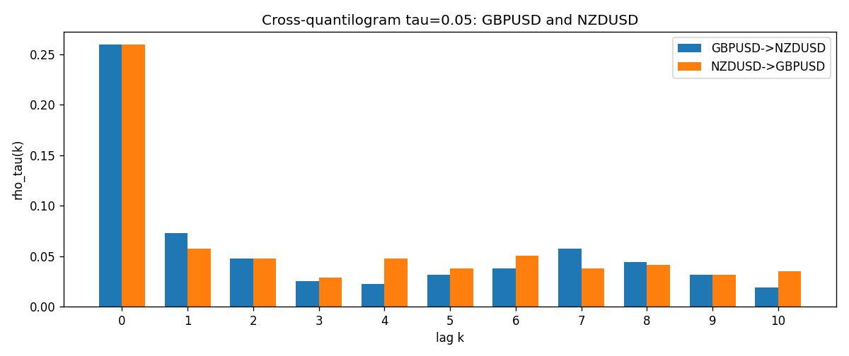

Data report
Matched rows and the CQ sheet are in the sibling Excel workbook named GBPUSD-NZDUSD_CQ_D1.xlsx. Embedding all rows as a Word table is impractical; this file holds column summaries and the first and last 15 matched rows.
Columns: time, GBPUSD_open, NZDUSD_open, GBPUSD_high, NZDUSD_high, GBPUSD_low, NZDUSD_low, GBPUSD_close, NZDUSD_close, GBPUSD_tick_volume, NZDUSD_tick_volume, GBPUSD_spread, NZDUSD_spread, GBPUSD_real_volume, NZDUSD_real_volume, GBPUSD_log_return, NZDUSD_log_return, GBPUSD_h_t005, NZDUSD_h_t005
Column summaries (matched calculation rows)
column | count | mean | std | min | 25% | 50% | 75% | max
GBPUSD_open | 7203 | 1.5160351 | 0.21820856 | 1.06854 | 1.32502 | 1.51126 | 1.63163 | 2.1066
NZDUSD_open | 7203 | 0.65617721 | 0.10827592 | 0.3913 | 0.59107 | 0.6683 | 0.72469 | 0.88218
GBPUSD_high | 7203 | 1.5223294 | 0.21877071 | 1.08366 | 1.3298 | 1.51797 | 1.63833 | 2.1161
NZDUSD_high | 7203 | 0.66009189 | 0.10877133 | 0.3961 | 0.594565 | 0.67188 | 0.729235 | 0.88421
GBPUSD_low | 7203 | 1.5097156 | 0.21743942 | 1.03518 | 1.319525 | 1.50315 | 1.62431 | 2.0983
NZDUSD_low | 7203 | 0.65248767 | 0.1078698 | 0.3897 | 0.587935 | 0.66402 | 0.72082 | 0.87988
GBPUSD_close | 7203 | 1.5161019 | 0.21816437 | 1.06879 | 1.32515 | 1.51122 | 1.63196 | 2.1065
NZDUSD_close | 7203 | 0.65624807 | 0.10827144 | 0.3907 | 0.591395 | 0.6683 | 0.724915 | 0.8822
GBPUSD_tick_volume | 7203 | 94800.961 | 153533.35 | 62 | 9991 | 52873 | 91772.5 | 1273370
NZDUSD_tick_volume | 7203 | 68552.383 | 123030.52 | 16 | 5500.5 | 33815 | 58467.5 | 1127682
GBPUSD_spread | 7203 | 26.976121 | 19.194852 | 0 | 11 | 20 | 50 | 50
NZDUSD_spread | 7203 | 30.373178 | 25.676979 | 0 | 9 | 17 | 50 | 80
GBPUSD_real_volume | 7203 | 3.5551025e+09 | 8.4426509e+10 | 0 | 0 | 0 | 0 | 2.4038164e+12
NZDUSD_real_volume | 7203 | 1.6657093e+10 | 8.4881524e+10 | 0 | 0 | 0 | 0 | 2.705649e+12
GBPUSD_log_return | 7203 | -2.372e-05 | 0.00564203 | -0.08388241 | -0.00312422 | 3.221e-05 | 0.0031735 | 0.03112653
NZDUSD_log_return | 7203 | 5.29e-06 | 0.00764545 | -0.07027433 | -0.00426254 | 0.00021291 | 0.00457891 | 0.05966839
GBPUSD_h_t005 | 6952 | 0.00135213 | 0.22073082 | -0.05 | -0.05 | -0.05 | -0.05 | 0.95
NZDUSD_h_t005 | 6952 | -0.00555236 | 0.2061023 | -0.05 | -0.05 | -0.05 | -0.05 | 0.95
First 15 matched rows (selected columns)
time | GBPUSD_log_return | NZDUSD_log_return | GBPUSD_h_t005 | NZDUSD_h_t005
1999-01-05 | -0.0028966287 | -0.0018597736 | nan | nan
1999-01-06 | -0.00060452184 | 0.0020455609 | nan | nan
1999-01-07 | -0.002118709 | 0.0062963171 | nan | nan
1999-01-08 | -0.0058954193 | -0.00055396548 | nan | nan
1999-01-11 | -0.0056851331 | 0.010290425 | nan | nan
1999-01-12 | 0.0022657001 | -0.0053157489 | nan | nan
1999-01-13 | 0.0091330396 | -0.0099742238 | nan | nan
1999-01-14 | 0.0019376331 | -0.00018564931 | nan | nan
1999-01-15 | -0.0017558204 | -0.00074294208 | nan | nan
1999-01-18 | 0.0012112405 | -0.0018597736 | nan | nan
1999-01-19 | 0.0018745281 | 0.0018597736 | nan | nan
1999-01-20 | -0.0049053846 | 0.0040793678 | nan | nan
1999-01-21 | 0.0031518998 | 0.0040627941 | nan | nan
1999-01-22 | 0.0024781662 | -0.012051689 | nan | nan
1999-01-25 | 0.0012066366 | -0.0035504102 | nan | nan
Last 15 matched rows (selected columns)
time | GBPUSD_log_return | NZDUSD_log_return | GBPUSD_h_t005 | NZDUSD_h_t005
2026-10-13 | 0.0036434319 | 0.0047326165 | -0.05 | -0.05
2026-10-14 | -0.0049164679 | -0.0037306483 | -0.05 | -0.05
2026-10-15 | 0.0065976411 | 0.0047634855 | -0.05 | -0.05
2026-10-16 | 0.0037592051 | 0.0057501001 | -0.05 | -0.05
2026-10-19 | -0.0017500314 | 0.0018917133 | -0.05 | -0.05
2026-10-20 | 0.0055923442 | 0.0037199341 | -0.05 | -0.05
2026-10-21 | 0.0012476328 | 0.0030923331 | -0.05 | -0.05
2026-10-22 | 0.00022396082 | -0.0033035227 | -0.05 | -0.05
2026-10-23 | -0.0021146949 | 0.0030929853 | -0.05 | -0.05
2026-10-26 | -0.0024340661 | -0.0028993932 | -0.05 | -0.05
2026-10-27 | -0.0023648393 | -0.00026399852 | -0.05 | -0.05
2026-10-28 | 0.0015771808 | -0.0097283914 | -0.05 | -0.05
2026-10-29 | 0.0035881935 | 0.00062190714 | -0.05 | -0.05
2026-10-30 | 0.0013450605 | 0.00019537668 | -0.05 | -0.05
2026-11-02 | 0.0010971256 | -0.0025962955 | -0.05 | -0.05

